Experiment No: 1
Date: 16-7-2008

FAMILIARIZATION OF COMPONENTS

AIM

To familiarize the given components

- DC power supply
- Multimeter
- Function Generator
- Cathode Ray Oscilloscope
- Bread board

COMPONENTS REQUIRED

1. DC power supply
- Multimeter
- Function Generator
- Cathode Ray Oscilloscope
- Resistor
- Capacitor
- Diode
- Bread board

THEORETICAL BACKGROUND

DC POWER SUPPLY
The DC power supply is the most common source of power supply required for the proper working of electronic devices such as diodes, zener diodes, transistors, FETs, SCRs, BJTs, vacuum tubes, etc. The DC power supply does not vary in the output. This is mainly due to the variation of the load and also because of the variation of AC input to the source of the DC supply. This kind of supplied load is known as Regulated power supply.

Active components need the application of DC supply on the electrodes or terminals. The emitter circuit of a bipolar junction transistor needs forward bias; the collector of the same component needs reverse bias DC, the anodes of the vacuum tubes use high voltage positive DC potential, the control guides need a negative potential etc. The blockwise placement of the components can be studied by knowing the functioning of the circuit. The transformer used is a step-down transformer used for a low voltage output, but a step-up transformer is used if the output required is high. The transformer is used to provide the require magnitude of the DC output voltage. A rectifier circuit consisting of diodes which converts the output of the transformer circuit into a pulsating DC consists of both AC components with a ripple factor of 0.48 for full wave rectifier output. The AC components should be eliminated. The filter circuit helps to smoothen the output by minimizing the ripples in the supply. Capacitors and inductors are used in filter circuits.

MULTIMETER

A multimeter is used to measure many electrical quantities. It can measure voltages (AC and DC), currents (AC and DC0 and resistances. A multimeter is a voltmeter, milliammeter and ohmmeter combined together. It has various ranges of voltage, current and resistance measurements.

A multimeter may also be used in diode testing and also in continuity tests.

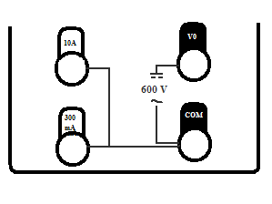
Input Jack
Volts, Ohms, Diode test

Amps

Milliamps

The black lead of the multimeter is always plugged into the common terminal. The red lead of the multimeter is plugged into the 10 Amps jack when currents greater than 300 Milliamps are to be measured. The red lead is plugged into the 300 Milliamps jack when measuring a current less than 300 Milliamps and the remaining jack is used for the measurement of voltage or resistance.

FUNCTION GENERATOR

Function generator is a piece of electronic test equipment used to generate electrical waveforms. These waveforms can be either repetitive, or single-shot in which case some kind of triggering source is required.

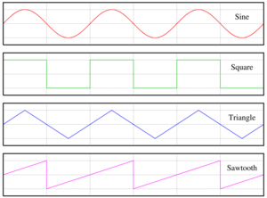

The resulting waveforms can be injected into a device under test and analyzed as they progress through the device, confirming operation of the device.

POWER: Push button switch for supplying power to instrument.

- DIGITAL DISPLAY (7- SEGMENT LED): 4- digit frequency/ amplitude meter. LED indicators for Hz, kHz, mV and V

- FREQ/AMP: Selects display of frequency or amplitude.

- AMP(Adjusting knob): Continuous adjustment of the output amplitude from 0 to -20dB when terminated with 50Ω.

- -20 dB, 20 dB (Push button): Two fixed attenuators, -20 dB each. They can e activated to give a total attenuation of 4_0 dB results. Including the amplitude control 4 the maximum attenuation amounts to -60 dB.

- OUTPUT (BNC connectors): Short circuit proof signal output of the generator. The output impedance is 50Ω switch selectable. Maximum output amplitude is 30 V_{pp}.

50 Ω/ 600 Ω: Push button when pressed selects 600 Ω else 50 Ω in released position.

- FUNCTION (4 position push buttons switch): Mode selection DC- Sine- Triangle- Square.

- DC (on), OFFSET (Adjusting knob): Adjustment of the positive or negative offset voltage. This DC voltage can be superimposed on the output signal. The maximum offset voltage is ± 15 V or ± 7.5 V when terminated with 50 Ω.

- OVERDRIVE: When working in the offset mode, the output amplifier is overdriven either in positive or in negative direction, the corresponding LED lit up. FVAR (Adjusting knob): Continuous and linear frequency adjustment from 1 Hz to 1 MHz in steps, selected with frequency range.

- FREQUENCY (7 position push button switch): Frequency coarse adjustment from 1 Hz to 1 MHz in 7 decade steps.

- VAR: When trigger output is selected in CMOS, output can be set with var.

- TRIG OUTPUT (BNC connectors): This short circuit proof output supplies a square signal in synchronous with output signal.

- TTL/ CMOS: Switch selects trigger output TTL or CMOS.

- FM IN (BNC connectors): Applying a DC voltage to this input will vary the oscillator frequency linearly to maximum of 1:100.

- AMPL (Adjusting knob): Attenuation of input voltage for FM input. This permits the user to change the sweep width.

CRO (Cathode Ray Oscilloscope)

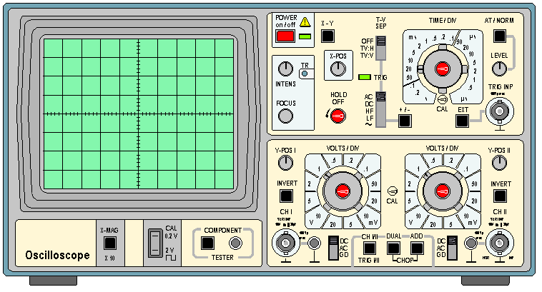

An oscilloscope is easily the most useful instrument available for testing circuits because it allows you to see the signals at different points in the circuit. The best way
of investigating an electronic system is to monitor signals at the input and output of each system block, checking that each block is operating as expected and is correctly linked to the next.

- POWER: Push button switch for supplying power to the instrument.

- X5: Switch when pushed inwards gives 5 times magnification of the X signal.

- XY: Switch when pressed cuts off the time base and allows access the external horizontal signal to be fed through CH II.

- CH-I/ CH-II/ TRIG I/ TRIG II: Switch when out selects and triggers CH-I and when pressed selects and triggers CH-II.

- MONO/ DUAL: Switch selects the dual operation.

- ALT/ CHOP/ ADD: Switch selects alternate or chopped in DUAL mode.

- TRIG. INP: Socket provided to feed external trigger signal in EXT mode.

- CALOUT: Socket provided for square wave output 200mV, used for probe compensation and checking vertical sensitivity.

- HOLDOFF: Controls hold off time between sweeps Normal position = full ccw.

- X – POS: Controls horizontal position of trace.

- EXT: Switch when pressed allows external triggering signal to be fed from socket marking TRIG INP.

- VAR: Controls the time speed in between 2 steps of TIME/ DIV switch. For calibration put this fully anticlockwise.

- LINE: Switch when pressed displayed signal gets synchronized with mains/ line frequency.

- ALT: Selects alternate trigger mode from CH - I and CH – II.

- +/-: Switch selects the slope of triggering, whether positive going or negative going. INV CH - II: Switch when pressed inverts the CH – II.

- INTENS: Controls the brightness of the trace.

- TR: Controls the alignment of the trace with graticule.

- CT: Switch when pressed starts CT operation.

- DC/ AC/ GD: Input coupling switch for each channel. In AC the signal is coupled through 0.1 MFD capacitor.

- CH - I(Y) & CH – II(X): BNC connectors serve as input connection for CH – I and CH – II. Channel II input connector also serves as horizontal external signal.

- CT – IN: To test any components in the CT mode, put one test probe in this socket and connect the other test probe in ground.

- VOLTS/ DIV: Switches select the sensitivity of each channel.

- Y POS I & II: Controls provided for vertical deflection of trace for each channel.

In order to prevent damage to the CRO it is necessary to avoid the use of extreme brightness for prolonged periods otherwise the phosphor on the tube face may be permanently burned. Therefore it is wise to reduce the intensity when not using the CRO for prolonged periods.

COMPONENTS

RESISTORS
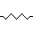
Resistors are passive components which restricts the flow of current. The flow of current through any material encounters an opposing force called resistance. It is measured in ohms, for which the symbol is Ω. It causes a voltage drop between the two terminals. The circuit symbol is shown below.

The resistance R is given by the formula,

R= V/I

- The important characters of a resistor are its resistance value, power dissipation

frequency characteristics, s Resistors are mainly of two types- fixed and variable.

FIXED RESISTORS
Some resistors are cylindrical, with the actual resistive material in the centre (composition resistors, now obsolete) or on the surface of the cylinder (film) resistors, and a conducting metal lead projecting along the axis of the cylinder at each end(axial lead). There are carbon film and metal film resistors. The photo above right shows a row of common resistors. Power resistors come in larger packages designed to dissipate heat efficiently. At high power levels, resistors tend to be wire wound types. Resistors used in computers and other devices are typically much smaller, often in surface-mount packages without wire leads. Resistors can also be built into integrated circuits as part of the fabrication process, using the semiconductor material as a resistor. But resistors made in this way are difficult to fabricate and may take up a lot of valuable chip area, so IC designers alternatively use a transistor-transistor or resistor-transistor configuration to simulate the resistor they require.

VARIABLE RESISTORS
The variable resistor is a resistor whose value can be adjusted by turning a shaft or sliding a control. They are also called potentiometers or rheostats and allow the resistance of the device to be altered by hand. The term rheostat is usually reserved for higher-powered devices, above about ½ watt. Variable resistors can be inexpensive single-turn types or multi-turn types with a helical element. Some variable resistors can be fitted with a mechanical display to count the turns. Variable resistors can sometimes be unreliable, because the wire or metal can corrode or wear.

COLOUR CODING IN RESISTORS

Four-band identification is the most commonly used color coding scheme on all resistors. It consists of four colored bands that are painted around the body of the resistor. The scheme is simple: The first two numbers are the first two significant digits of the resistance value, the third is a multiplier, and the fourth is the tolerance of the value. The tolerance for a 4-band resistor will be 2%, 5%, or 10%.

COLOUR CODING
COLOR 1ST BAND 2ND BAND 3RD BAND 4TH BAND
BLACK 0 0 10⁰
BROWN 1 1 10¹ ±1% (F)
RED 2 2 10² ±2% (G)
ORANGE 3 3 10³
YELLOW 4 4 10⁴
GREEN 5 5 10⁵ ±0.5% (D)
BLUE 6 6 10⁶ ±0.25% (C)
VIOLET 7 7 10⁷ ±0.1% (B)
GREY 8 8 10⁸ ±0.05% (A)
WHITE 9 9 10⁹
GOLD 0.1 ±5% (J)
SILVER 0.01 ±10% (K)
NONE ±20% (M)

CAPACITORS

A capacitor is an electrical device that can store energy in the electric field between a pair of closely spaced conductors (called 'plates'). When current is passed through the capacitor, electric charges of equal magnitude, but opposite sign, build up on each plate.
Capacitors are used in electrical circuits as energy-storage devices. They can also be used
to differentiate between high-frequency and low-frequency signals and this makes them useful in electronic filters
A capacitor consists of two conductive electrodes, or plates, separated by an insulator. (The insulator inside a capacitor is sometimes called the dielectric). When the capacitor is in its minimum-energy state, each plate contains equal amounts of electrons and protons and is therefore, overall, electrically neutral. When an electric field is applied across the terminals by an external circuit, excess electrons are forced into one plate, giving it a net negative charge, and some are pulled out of the other plate, giving it a net positive charge. The net charge on the capacitor, even when it is energised, remains zero. The number of electrons added to one plate is equal to the number removed from the other. Even though one plate is now electrically positive, and the other plate is electrically negative, the capacitor as a whole remains electrically neutral. (This fact is named Kirchhoff's current law).

Because of the electric field between the two plates of an energised capacitor, the electrons in the negative plate are attracted towards the positive plate. Since the electrons cannot cross the dielectric, their concentration is highest on the side of the negative plate facing the gap. Conversely, the electrons in the positive plate are repelled from the negative plate by the electric field. Their concentration is lowest on the side of the positive plate nearest the gap. The protons in both plates are fixed in position by the atomic structure of the material.
The capacitor's capacitance (C) is a measure of the amount of charge (Q) stored on each plate for a given potential difference or voltage (V) which appears between the plates:

C=Q/V
In SI units, a capacitor has a capacitance of one farad when one coulomb of charge causes a potential difference of one volt across the plates. Since the farad is a very large unit, values of capacitors are usually expressed in microfarads (µF), nanofarads (nF) or picofarads (pF).

DIODES
Diodes allow electricity to flow in only one direction. The arrow of the circuit symbol shows the direction in which the current can flow. Diodes are the electrical version of a valve and early diodes were actually called valves.

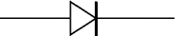

FORWARD VOLTAGE DROP
Electricity uses up a little energy pushing its way through the diode, rather like a person pushing through a door with a spring. This means that there is a small voltage across a conducting diode, it is called the forward voltage drop and is about 0.7V for all normal diodes which are made from silicon. The forward voltage drop of a diode is almost constant whatever the current passing through the diode so they have a very steep characteristic (current-voltage graph).

REVERSE VOLTAGE DROP
When a reverse voltage is applied a perfect diode does not conduct, but all real diodes leak a very tiny current of a few µA or less. This can be ignored in most circuits because it will be very much smaller than the current flowing in the forward direction. However, all diodes have a maximum reverse voltage (usually 50V or more) and if this is exceeded the diode will fail and pass a large current in the reverse direction, this is called breakdown.

BREAD BOARD
A solderless bread board is a multipurpose board with 128 groups and 5 connected terminals. In each we can insert a pin of the components. The inserted components are caught between two plates with spring action. The 128 groups of terminals are arranged on the upper and lower side of the bread board in two sets of 64 each. Each group on both sides marked with 1-62 except the first two groups. It means that the numbering starts from the third group and the first two groups are not numbered.

PROCEDURE

The following components were analyzed
. DC power supply
2. Multimeter
- Function Generator
- Cathode Ray Oscilloscope
- Bread board

APPLICATIONS

Active components need the application of dc on various electrode or terminals. The anode of the vacuum tubes use high voltage positive dc potential, the control guides need a negative potential. Biasing is involved in zener diodes, FET’s, SCR’s, UJT’s, gas tubes etc.
Multimeter is used to measure many electrical quantities.
Function generator can be used to generate multiple waveforms.
The cathode-ray oscilloscope is one of the most widely used test instruments; its commercial, engineering, and scientific applications include acoustic research, television-production engineering, and electronics design. It is also used in electrochemical measurement as a recording device connected to a polo graph with a high potential sweep rate. One of the most frequent uses of scopes is in trouble shooting malfunctioning electronic equipment.
In integrated circuits special resistors are used. In power hybrid applications a high a voltage resistor can be used as current sensor.

CONCLUSION

The aim of this experiment is to familiarize with the various instruments and components which are commonly used in electronics.The completion of this experiment makes it possible to:
- Describe the characteristics and applications of a broad range of electrical and electronic components, devices and equipments.
- Select the appropriate test equipment and procedures required for each experiment.
- Wire the circuits correctly according to the circuit diagram.
- Measure the performance of an electronic or electrical device properly.
- Analyze the readings and the graphs to obtain accurate results.
- Predict the performance of a device from its characteristics.

Experiment No: 2
Date: 23-7-2008

DIODE CHARACTERISTICS

AIM

To study and plot:
- The forward characteristics of Silicon diode.
- The reverse characteristics of Zener diode.

COMPONENTS REQUIRED

COMPONENTS | QUANTITY
1N4001 (Silicon diode) | 1
SZ 6.8 (Zener diode) | 1
Resistor – 100Ω | 1
Ammeter – 0-10mA | 1
Ammeter – 0-100mA | 1
Voltmeter – 0-1V | 1
Voltmeter – 0-10V | 1
Rheostat - 330 Ω/1.1A | 1
Power supply – 0-30V Dual
Bread board

THEORY

A Diode is an electrical device allowing current to move through it in one direction with far greater ease than in the other. The p-n junction diode is obtained by joining a piece of p-type and n-type material such that the crystal structure remains continuous at the boundary. When the two layers are joined together, the electrons in the N region are attracted by the relatively positive holes in the P region. Due to this, both the charge carriers approach the junction and recombine (the fact is that hole is an electron-deficient position). Due to this, there is neutralization of majority carriers at the junction, forming the depletion layer. So, that region is depleted of charges and acts as an insulator.
But the depletion region can’t grow without limit. As the layer widens, the insulating properties becomes so prominent that the attractive movement of the charge carriers is overpowered by the insulation and the flow of charge carriers goes down. So, due to the accumulation of charge carriers, a potential is developed across the junction and this potential is called barrier potential. For silicon diodes, it is about 0.6V.
If an external voltage is given such that its potential is equal to the barrier potential (0.6V), and the positive pole is connected to the P region and negative pole to N region, there won’t be any considerable flow of current across the junction. This is since the whole applied voltage is dropped across the depletion layer and nothing is left to energize the charge carriers. But if the voltage is increased further, the depletion layer’s insulation becomes ineffective compared to the repulsive force of the external voltage source’s poles. So, the charge carriers are energized and they begin to move across the junction. Then the diode is said to be in ‘forward bias’.

A Zener diode is also a silicon diode, except for the fact that it is heavily doped. So, it works like a normal diode in the forward region, but can withstand much heavier currents in the reverse region, beyond the breakdown voltage called ‘Zener knee voltage’.
Just like other diodes, the Zener also can drop a voltage of 0.6V in the forward region. But for other diodes, in the reverse bias condition, if the voltage exceeds the breakdown voltage, the current in the circuit becomes very high. If there are no limiting resistors, the diode will be damaged permanently. Valence electrons which break free under the influence of the applied electric field can be accelerated enough that they can knock loose other electrons and the subsequent collisions quickly become an avalanche. When this process is taking place, very small changes in voltage can cause very large changes in current. The Zener is designed to withstand just that. The breakdown process depends upon the applied electric field, so by changing the thickness of the layer to which the voltage is applied, Zener diodes can be formed which break down at voltages from about 4 volts to several hundred volts.
Zener diode is designed to have a greatly reduced breakdown voltage and heavy doping levels. Due to heavy doping, electrons can tunnel from the valence band of the P-type material to the conduction band of the N-type material.

The Zener Diode is used as a voltage regulator. (In breakdown, even if current varies considerably, the voltage remains almost constant)

PROCEDURE

- Identify the anode and cathode of the diode using multimeter, set up the circuit on the bread board as in diagram.
- Switch on the power supplies and vary the rheostat so that the voltmeter readings vary from 0 to 1V in steps of 0.1V. Note down the readings of voltmeter and ammeter for each setting of rheostat. Tabulate the readings and plot the graph for the forward bias condition. Reverse characteristics of Si diode can’t be measured practically. It is in nanoamperes.
- Repeat step (2) using Ge diode. Plot forward characteristics.
- For Zener reverse characteristics, connect the diode according to the circuit. Vary the rheostat and note the ammeter and voltmeter readings. Plot the graph and find the Zener breakdown voltage.

CIRCUIT DIAGRAMS

Si diode forward characteristics.

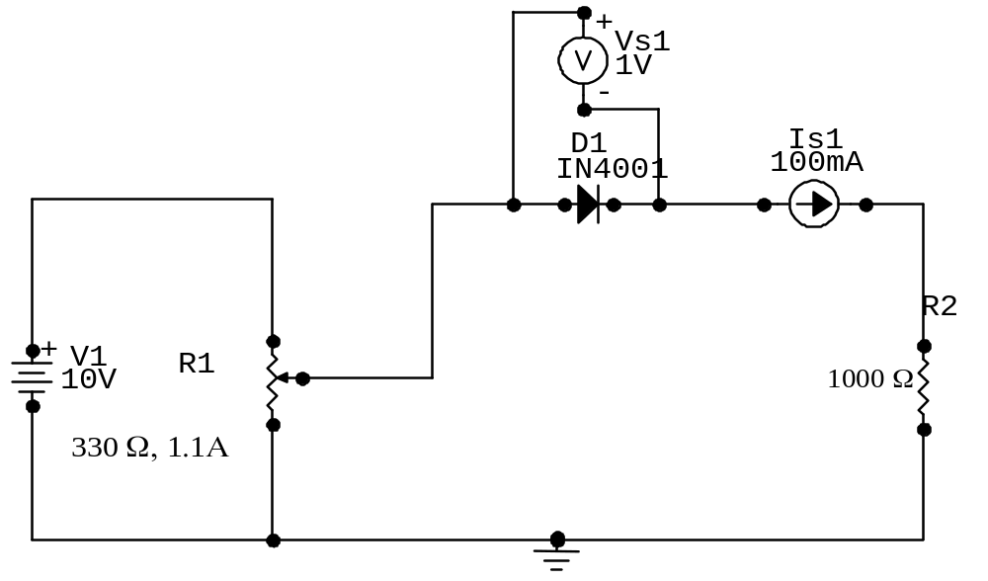

Ge Diode forward characteristics.

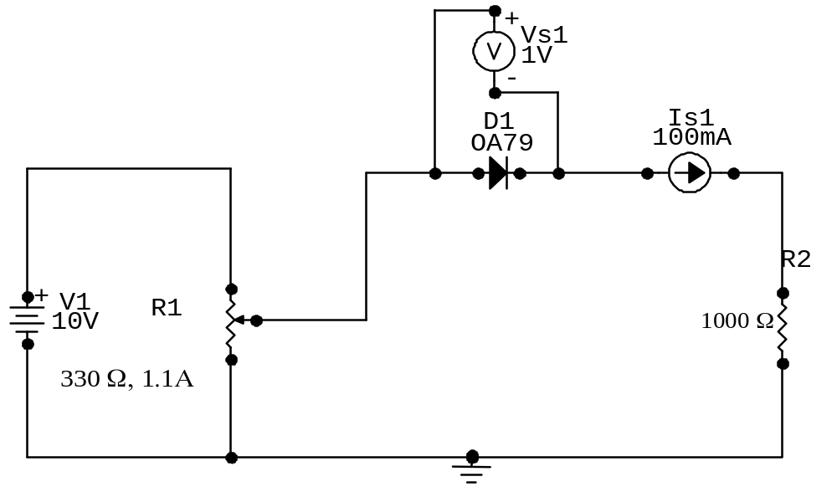

Zener diode reverse characteristics.

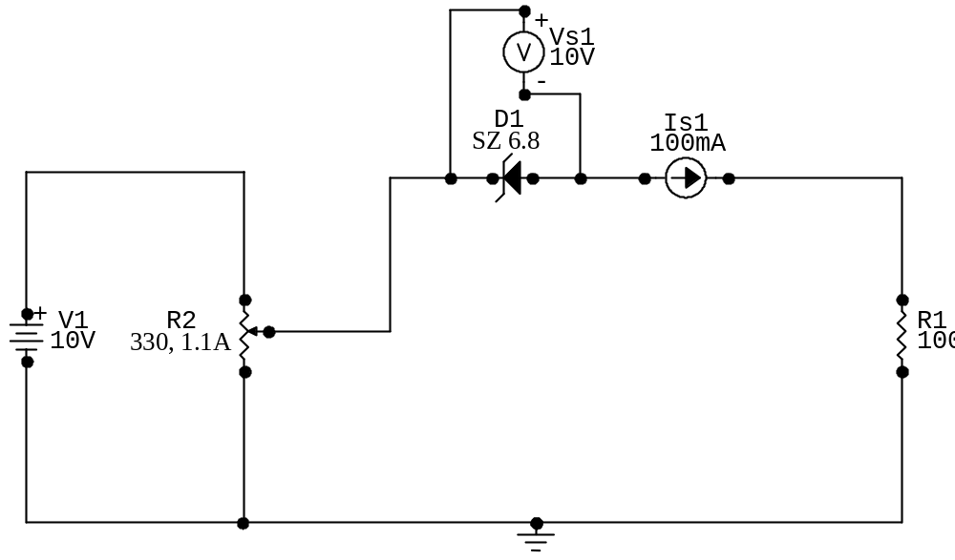

OBSERVATION TABLES

Forward characteristics of Si diode.

V(volts) | I(mA)
0.1 | 0.0
0.2 | 0.2
0.3 | 0.2
0.4 | 0.3
0.5 | 0.6
0.6 | 3.5
0.64 | 7
0.65 | 9.0
0.66 | 10

Ge Diode

V(volts) | I(mA)
0.1 | 0.0
0.2 | 0.2
0.3 | 0.4
0.4 | 0.8
0.5 | 1.4
0.6 | 2.2
0.7 | 3.0
0.8 | 3.8
0.9 | 4.4
1.0 | 5.2

Reverse characteristics of Zener diode.

V(volts) | I(mA)
1 | 0
2 | 0
3 | 0
4 | 0
5 | 0
6.2 | 0
6.4 | 1.0
6.7 | 2.0
6.8 | 8.0
6.9 | 22

CALCULATIONS

Si Diode forward biased at 0.6 V

Static Resistance = V/I = 0.64 . = 91.43Ω
7x10⁻³

Dynamic Resistance=ΔV/ΔI = .66-.64 . = 6.67Ω
3x10⁻³

Ge Diode forward biased at .4V
Static Resistance = V/I = 0.6 . = 272.27Ω
2.2x10⁻³

Dynamic Resistance=ΔV/ΔI = .66-..40 . = 142.5Ω
(2.2-0.8)x10⁻³

Zener Diode break down voltage is 6.6 V

Static Resistance = V/I = 6.8 . = 850.5Ω
8.1x10⁻³

Dynamic Resistance=ΔV/ΔI = 0.1 . = 25Ω
4.0 x10⁻³

RESULT

The forward and reverse characteristics of the given diodes have been studied and plotted.

Silicon diode forward biased = 0.6V
Static resistance = 91.43Ω
Dynamic resistance = 6.67Ω

Germanium diode forward biased = 0.4V
Static resistance = 272.2Ω
Dynamic resistance = 142.8Ω

Zener diode reverse biased = 6.6V
Static resistance = 850.5Ω
Dynamic resistance = 25Ω

